# Mobile Application Development Lab

## Exercis-2

S.Hariharan 1831017

### 1.Calculate the difference between two dates. (Display the output in No. of Year, No. of Month, No. of Day, No. of Hour, No. of Minute, No. of Seconds)

SOURCE CODE:

MainActivity.java

package com.example.settheory;  
  
import androidx.appcompat.app.AppCompatActivity;  
  
import android.app.DatePickerDialog;  
import android.app.TimePickerDialog;  
import android.os.Bundle;  
import android.view.View;  
import android.widget.Button;  
import android.widget.CalendarView;  
import android.widget.DatePicker;  
import android.widget.EditText;  
import android.widget.TextView;  
import android.widget.TimePicker;  
  
import java.text.ParseException;  
import java.text.SimpleDateFormat;  
import java.util.Calendar;  
import java.util.Date;  
import java.util.concurrent.TimeUnit;  
  
public class MainActivity extends AppCompatActivity {  
  
 EditText date2,date1;  
 Button difference_date;  
 TextView result;  
 protected void onCreate(Bundle savedInstanceState) {  
 super.onCreate(savedInstanceState);  
 setContentView(R.layout.*activity_main*);  
 this.setTitle("Date Calculator");  
  
 date2=(EditText) findViewById(R.id.*date2*);  
 date1=(EditText) findViewById(R.id.*Date1*);  
 difference_date=(Button) findViewById(R.id.*button2*);  
 result=(TextView) findViewById(R.id.*textView*);  
  
 date1.setOnClickListener(new View.OnClickListener(){  
  
 public void onClick(View v)  
 {  
 showDateTimeDialog(date1);  
 }  
 });  
 date2.setOnClickListener(new View.OnClickListener(){  
  
 public void onClick(View v)  
 {  
 showDateTimeDialog(date2);  
 }  
 });  
  
 difference_date.setOnClickListener(new View.OnClickListener(){  
 @Override  
 public void onClick(View v) {  
 showDifference(date1,date2);  
 }  
 });  
 }  
  
  
 private void showDifference(EditText t1,EditText t2)  
 {  
 SimpleDateFormat sd=new SimpleDateFormat("dd-MM-yyyy HH:mm");  
 String dateone= t1.getText().toString();  
 String datetwo=t2.getText().toString();  
 Date d1 = null;  
 try {  
 d1 = sd.parse(dateone);  
 Date d2 = sd.parse(datetwo);  
 long difference_In_Time = d2.getTime() - d1.getTime();  
 long difference_In_Seconds = TimeUnit.*MILLISECONDS*.toSeconds(difference_In_Time) % 60;  
 long difference_In_Minutes = TimeUnit.*MILLISECONDS*.toMinutes(difference_In_Time)% 60;  
 long difference_In_Hours = TimeUnit.*MILLISECONDS*.toHours(difference_In_Time) % 24;  
 long difference_In_Days = TimeUnit.*MILLISECONDS*.toDays(difference_In_Time) % 365;  
 long difference_In_Month=TimeUnit.*MILLISECONDS*.toDays(difference_In_Time) / 30;  
 long difference_In_Years = TimeUnit.*MILLISECONDS*.toDays(difference_In_Time) / 365;  
 String value1=Long.*toString*(difference_In_Days);  
 String value2=Long.*toString*(difference_In_Time);  
 String value3=Long.*toString*(difference_In_Minutes);  
 String value4=Long.*toString*(difference_In_Hours);  
 String value5=Long.*toString*(difference_In_Years);  
 String value6=Long.*toString*(difference_In_Seconds);  
 String value7=Long.*toString*(difference_In_Month);  
 result.setText(" ");  
 result.setText("Time:"+value2+"\nYears:"+value5+"\tMonth:"+value7+"\tDays:"+value1+"\n Hours:"+value4+"\tMinutes:"+value3+"\t Sec:"+value6);  
 } catch (ParseException e) {  
 e.printStackTrace();  
 }  
  
 }  
  
 private void showDateTimeDialog(EditText date1)  
 {  
 Calendar calendar= Calendar.*getInstance*();  
 DatePickerDialog.OnDateSetListener datesetListener=new DatePickerDialog.OnDateSetListener() {  
 @Override  
 public void onDateSet(DatePicker view, int year, int month, int dayOfMonth) {  
 calendar.set(Calendar.*YEAR*, year);  
 calendar.set(Calendar.*MONTH*, month);  
 calendar.set(Calendar.*DAY_OF_MONTH*, dayOfMonth);  
  
 TimePickerDialog.OnTimeSetListener timesetlistener = new TimePickerDialog.OnTimeSetListener() {  
  
 public void onTimeSet(TimePicker view,int hourOfDay,int minute)  
 {  
 calendar.set(Calendar.*HOUR_OF_DAY*,hourOfDay);  
 calendar.set(Calendar.*MINUTE*,minute);  
 SimpleDateFormat sd=new SimpleDateFormat("dd-MM-yyyy HH:mm");  
  
 date1.setText(sd.format(calendar.getTime()));  
 }  
 };  
  
 new TimePickerDialog(MainActivity.this,timesetlistener,calendar.get(Calendar.*HOUR_OF_DAY*),calendar.get(Calendar.*MINUTE*),false).show();  
 }  
  
 };  
 new DatePickerDialog(MainActivity.this,datesetListener,calendar.get(Calendar.*YEAR*),calendar.get(Calendar.*MONTH*),calendar.get(Calendar.*DAY_OF_MONTH*)).show();  
 }  
}

### OUTPUT:

Tested with OPPO REALME mobile with USB debugging

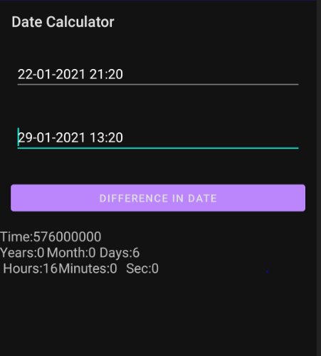

1. Perform Set theory operations such as Union, Minus, Intersection for the group of data.

SOURCE CODE:

MainActivity.java

package com.example.settheory;  
  
import android.graphics.Color;  
import android.os.Bundle;  
import android.view.View;  
import android.widget.Button;  
import android.widget.EditText;  
import android.widget.TextView;  
  
import androidx.appcompat.app.AppCompatActivity;  
  
import java.util.ArrayList;  
  
import static com.example.settheory.Set.*getvalues*;  
public class MainActivity extends AppCompatActivity {  
 TextView t1, t2, t3, t4;  
 EditText e1, e2, e3;  
 Button b1;  
  
 @Override  
 protected void onCreate(Bundle savedInstanceState) {  
 super.onCreate(savedInstanceState);  
 setContentView(R.layout.*activity_main*);  
 ArrayList<Integer> a1 = new ArrayList<Integer>();  
 ArrayList<Integer> a2 = new ArrayList<Integer>();  
 a1.add(1);  
 a1.add(2);  
 a1.add(3);  
 a2.add(3);  
 a2.add(4);  
 a2.add(5);  
 b1 = (Button) findViewById(R.id.*button*);  
 e1 = (EditText) findViewById(R.id.*edit1*);  
 e2 = (EditText) findViewById(R.id.*edit2*);  
 e3 = (EditText) findViewById(R.id.*edit3*);  
 t1 = (TextView) findViewById(R.id.*text1*);  
 t2 = (TextView) findViewById(R.id.*text2*);  
 t3 = (TextView) findViewById(R.id.*text3*);  
 t4 = (TextView) findViewById(R.id.*text4*);  
 t1.setTextColor(Color.*YELLOW*);  
 t2.setTextColor(Color.*YELLOW*);  
 t3.setTextColor(Color.*YELLOW*);  
 t4.setTextColor(Color.*YELLOW*);  
 b1.setOnClickListener(new View.OnClickListener() {  
 public void onClick(View v) {  
 String str1 = e1.getText().toString();  
 String str2 = e2.getText().toString();  
 String[] arr1 = str1.split(" ");  
 String[] arr2 = str2.split(" ");  
 ArrayList<Integer> a1 = new ArrayList<Integer>();  
 for (String s : arr1) {  
 a1.add(Integer.*parseInt*(s));  
 }  
 ArrayList<Integer> a2 = new ArrayList<Integer>();  
 for (String s : arr2) {  
 a2.add(Integer.*parseInt*(s));  
 }  
 String c = e3.getText().toString();  
 ArrayList<Integer> res = Set.*getvalues*(a1, a2, c);  
 t4.setText("");  
 String result = res.toString();  
 t4.setText(result);  
 }  
 });  
 }  
}

}

Activity_main.xml

<?xml version="1.0" encoding="utf-8"?>

<androidx.constraintlayout.widget.ConstraintLayout xmlns:android="<http://schemas.android.com/apk/res/android>"

xmlns:app="<http://schemas.android.com/apk/res-auto>" xmlns:tools="<http://schemas.android.com/tools>" android:layout_width="match_parent" android:layout_height="match_parent" android:background="@color/black" tools:context=".MainActivity">

<Button

android:id="@+id/button" android:layout_width="121dp" android:layout_height="0dp" android:layout_marginBottom="25dp" android:text="@string/b1" app:layout_constraintBottom_toTopOf="@+id/text4" app:layout_constraintEnd_toEndOf="parent" app:layout_constraintStart_toStartOf="parent" app:layout_constraintTop_toBottomOf="@+id/edit3" />

<TextView

android:id="@+id/text1" android:layout_width="159dp" android:layout_height="0dp" android:layout_marginTop="34dp" android:layout_marginBottom="27dp" android:text="@string/t1" app:layout_constraintBottom_toTopOf="@+id/edit1" app:layout_constraintEnd_toEndOf="parent" app:layout_constraintStart_toStartOf="parent" app:layout_constraintTop_toTopOf="parent" />

<TextView

android:id="@+id/text2" android:layout_width="163dp" android:layout_height="0dp" android:layout_marginBottom="24dp" android:text="@string/t2" app:layout_constraintBottom_toTopOf="@+id/edit2" app:layout_constraintEnd_toEndOf="parent" app:layout_constraintStart_toStartOf="parent" app:layout_constraintTop_toBottomOf="@+id/edit1" />

<TextView

android:id="@+id/text3" android:layout_width="208dp" android:layout_height="0dp" android:layout_marginBottom="21dp" android:text="@string/t3" app:layout_constraintBottom_toTopOf="@+id/edit3" app:layout_constraintEnd_toEndOf="parent" app:layout_constraintStart_toStartOf="parent" app:layout_constraintTop_toBottomOf="@+id/edit2" />

<TextView

android:id="@+id/text4" android:layout_width="203dp" android:layout_height="0dp" android:layout_marginBottom="15dp" android:text="@string/t4" app:layout_constraintBottom_toBottomOf="parent" app:layout_constraintEnd_toEndOf="parent" app:layout_constraintStart_toStartOf="parent"

app:layout_constraintTop_toBottomOf="@+id/button" />

<EditText

android:id="@+id/edit1" android:layout_width="0dp" android:layout_height="0dp" android:layout_marginBottom="21dp" android:ems="10" android:inputType="textPersonName" android:text="@string/e1" app:layout_constraintBottom_toTopOf="@+id/text2" app:layout_constraintEnd_toEndOf="@+id/text3" app:layout_constraintStart_toStartOf="@+id/edit2"

app:layout_constraintTop_toBottomOf="@+id/text1" />

<EditText

android:id="@+id/edit2" android:layout_width="245dp" android:layout_height="0dp" android:layout_marginBottom="28dp" android:ems="10" android:inputType="textPersonName" android:text="@string/e2" app:layout_constraintBottom_toTopOf="@+id/text3" app:layout_constraintEnd_toEndOf="parent" app:layout_constraintStart_toStartOf="parent"

app:layout_constraintTop_toBottomOf="@+id/text2" />

<EditText

android:id="@+id/edit3" android:layout_width="99dp" android:layout_height="0dp" android:layout_marginBottom="45dp" android:ems="10" android:inputType="textPersonName" android:text="@string/e3" app:layout_constraintBottom_toTopOf="@+id/button" app:layout_constraintEnd_toEndOf="parent" app:layout_constraintStart_toStartOf="parent"

app:layout_constraintTop_toBottomOf="@+id/text3" />

</androidx.constraintlayout.widget.ConstraintLayout>

### Set.java

package com.example.setapplication; import java.util.ArrayList;

public class Set {

public static ArrayList<Integer> getvalues(ArrayList<Integer> a1,

ArrayList<Integer> a2, String c) { ArrayList<Integer> op1 = new ArrayList<Integer>();

int k = 0; switch (c) {

case "+":

a1.removeAll(a2); a1.addAll(a2); op1 = a1;

break; case "*":

a1.retainAll(a2); op1 = a1;

break; case "-":

for (int i = 0; i < a1.size(); i++) { k = 0;

for (int j = 0; j < a2.size(); j++) { if (a1.get(i) == a2.get(j))

k = 1;

}

if (k == 0)

op1.add(a1.get(i));

}

break;

}

return op1;

}

}

OUTPUT:

Tested with OPPO REALME mobile with USB debugging

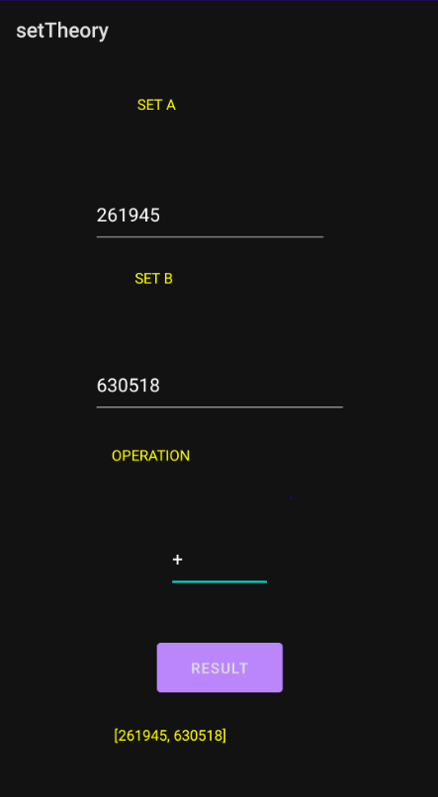

3.Perform matrix operations like Transpose, Lower Diagonal and Upper Diagonal

SOURCE CODE:

MainActivity.java

package com.example.matrixoperation;

import androidx.appcompat.app.AppCompatActivity; import android.graphics.Color;

import android.os.Bundle; import android.view.View; import android.widget.Button; import android.widget.EditText; import android.widget.TextView;

import java.util.Arrays;

public class MainActivity extends AppCompatActivity { TextView t1, t2;

EditText e1; Button b1;

@Override

protected void onCreate(Bundle savedInstanceState) { int A[][] = { {1, 1, 1, 1},

{2, 2, 2, 2},

{3, 3, 3, 3},

{4, 4, 4, 4}};

int N = 4;

super.onCreate(savedInstanceState); setContentView(R.layout.*activity_main*); e1 = (EditText) findViewById(R.id.*edit1*); b1 = (Button) findViewById(R.id.*button*); t1 = (TextView) findViewById(R.id.*text1*); t2 = (TextView) findViewById(R.id.*text2*); t1.setTextColor(Color.*WHITE*); t2.setTextColor(Color.*WHITE*); e1.setBackgroundColor(Color.*BLUE*); b1.setBackgroundColor(Color.*RED*);

b1.setOnClickListener(new View.OnClickListener() { public void onClick(View v) {

if (e1.getText().toString().equals("T")) {

int B[][] = new int[N][N],i,j; for (i = 0; i < N; i++) {

for (j = 0; j < N; j++) { B[i][j] = A[j][i];

}

}

t2.setText(Arrays.*deepToString*(B));

}

if(e1.getText().toString().equals("U")) {

for (int i = 0; i < N; i++) { for (int j = 0; j < N; j++) {

if (i > j) {

A[i][j] = 0;

}

}

t2.setText(Arrays.*deepToString*(A));

}

if (e1.getText().toString().equals("L")) { for (int i = 0; i < N; i++) {

for (int j = 0; j < N; j++) { if (j > i) {

A[i][j] = 0;

}

}

}

t2.setText(Arrays.*deepToString*(A));

}

}

}

});

}

}

Activity_main.xml

<?xml version="1.0" encoding="utf-8"?>

<androidx.constraintlayout.widget.ConstraintLayout xmlns:android="<http://schemas.android.com/apk/res/android>"

xmlns:app="<http://schemas.android.com/apk/res-auto>" xmlns:tools="<http://schemas.android.com/tools>" android:layout_width="match_parent" android:layout_height="match_parent" android:background="@color/black" tools:context=".MainActivity">

<TextView

android:id="@+id/text1" android:layout_width="0dp" android:layout_height="0dp" android:layout_marginStart="48dp" android:layout_marginLeft="48dp"

android:layout_marginTop="86dp" android:layout_marginEnd="48dp" android:layout_marginRight="48dp" android:layout_marginBottom="46dp" android:text="@string/textbox1" app:layout_constraintBottom_toTopOf="@+id/edit1" app:layout_constraintEnd_toEndOf="parent" app:layout_constraintStart_toStartOf="parent" app:layout_constraintTop_toTopOf="parent" />

<EditText

android:id="@+id/edit1" android:layout_width="207dp" android:layout_height="0dp" android:layout_marginBottom="77dp" android:ems="10" android:inputType="textPersonName" android:text="@string/editbox1" app:layout_constraintBottom_toTopOf="@+id/button" app:layout_constraintEnd_toEndOf="parent" app:layout_constraintStart_toStartOf="parent"

app:layout_constraintTop_toBottomOf="@+id/text1" />

<Button

android:id="@+id/button" android:layout_width="141dp" android:layout_height="0dp" android:layout_marginBottom="48dp" android:text="@string/button1" app:layout_constraintBottom_toTopOf="@+id/text2" app:layout_constraintEnd_toEndOf="parent" app:layout_constraintStart_toStartOf="parent" app:layout_constraintTop_toBottomOf="@+id/edit1" />

<TextView

android:id="@+id/text2" android:layout_width="0dp" android:layout_height="0dp" android:layout_marginStart="45dp" android:layout_marginLeft="45dp" android:layout_marginEnd="45dp" android:layout_marginRight="45dp" android:layout_marginBottom="49dp" android:text="@string/textbox2" app:layout_constraintBottom_toBottomOf="parent" app:layout_constraintEnd_toEndOf="parent" app:layout_constraintStart_toStartOf="parent"

app:layout_constraintTop_toBottomOf="@+id/button" />

</androidx.constraintlayout.widget.ConstraintLayout>

### OUTPUT:

Tested with OPPO REALME mobile with USB debugging

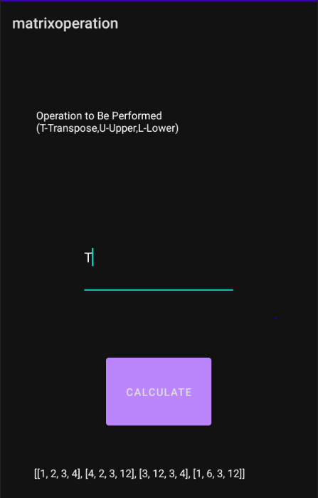

4.Convert the figure into words in currency.

SOURCE CODE:

Main_Activity.java

package com.example.currencytoword;  
  
import androidx.appcompat.app.AppCompatActivity;  
  
import android.os.Bundle;  
import android.view.View;  
import android.widget.Button;  
import android.widget.EditText;  
import android.widget.TextView;  
  
  
public class MainActivity extends AppCompatActivity {  
  
 EditText currency;  
 Button convert;  
 TextView result;  
 @Override  
 protected void onCreate(Bundle savedInstanceState) {  
 super.onCreate(savedInstanceState);  
 setContentView(R.layout.*activity_main*);  
 currency=(EditText) findViewById(R.id.*editTextNumber*);  
 convert=(Button) findViewById(R.id.*button*);  
 result=(TextView) findViewById(R.id.*textView*);  
  
 convert.setOnClickListener(new View.OnClickListener(){  
  
 @Override  
 public void onClick(View v) {  
 int num=Integer.*parseInt*(currency.getText().toString());  
 result.setText(numToWords(num)+"Only");  
 }  
 });  
 }  
 private String numToWords (int n){ //optional  
 NumberToWordsConverter ntw = new NumberToWordsConverter(); // directly implement this  
 return ntw.*convert*(n);  
 }  
}

NumberToWordsConverter.java

package com.example.currencytoword;  
  
public class NumberToWordsConverter {  
 public static final String[] *units* = {"", "One", "Two", "Three", "Four",  
 "Five", "Six", "Seven", "Eight", "Nine", "Ten", "Eleven", "Twelve",  
 "Thirteen", "Fourteen", "Fifteen", "Sixteen", "Seventeen",  
 "Eighteen", "Nineteen"};  
  
 public static final String[] *tens* = {  
 "", "", "Twenty", "Thirty", "Forty", "Fifty", "Sixty", "Seventy", "Eighty", "Ninety"  
 };  
  
 public static String convert(final int n) {  
 if (n < 0) {  
 return "Minus " + *convert*(-n);  
 }  
  
 if (n < 20) {  
 return *units*[n];  
 }  
  
 if (n < 100) {  
 return *tens*[n / 10] + ((n % 10 != 0) ? " " : "") + *units*[n % 10];  
 }  
  
 if (n < 1000) {  
 return *units*[n / 100] + " Hundred" + ((n % 100 != 0) ? " " : "") + *convert*(n % 100);  
 }  
  
 if (n < 100000) {  
 return *convert*(n / 1000) + " Thousand" + ((n % 10000 != 0) ? " " : "") + *convert*(n % 1000);  
 }  
  
 if (n < 10000000) {  
 return *convert*(n / 100000) + " Lakh" + ((n % 100000 != 0) ? " " : "") + *convert*(n % 100000);  
 }  
  
 return *convert*(n / 10000000) + " Crore" + ((n % 10000000 != 0) ? " " : "") + *convert*(n % 10000000);  
 }  
}

OUTPUT:

Tested with OPPO REALME mobile with USB debugging

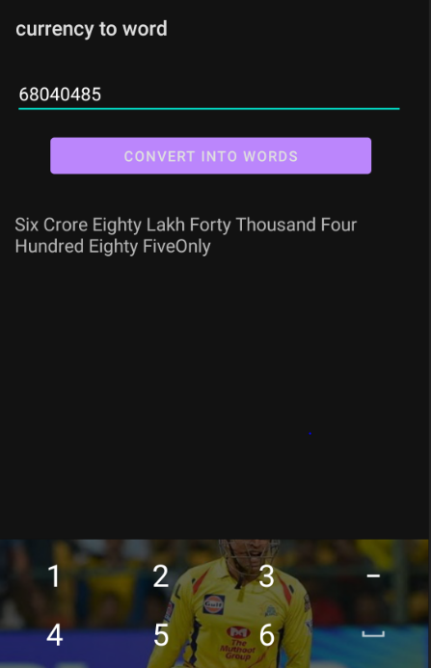

### 5.Calculate LCM, GCF, HCF, GCD, Standard Deviation and Variance

SOURCE CODE:

MainActivity.java

package com.example.statisticsconversions; import androidx.appcompat.app.AppCompatActivity;

import android.graphics.Color; import android.os.Bundle; import android.view.View; import android.widget.Button; import android.widget.EditText; import android.widget.TextView;

import java.util.Arrays;

public class MainActivity extends AppCompatActivity {

EditText e1,e2,choice; Button button1;

TextView t1,t2,t3,result; @Override

protected void onCreate(Bundle savedInstanceState) { super.onCreate(savedInstanceState); setContentView(R.layout.*activity_main*);

e1 = (EditText) findViewById(R.id.*edit1*); e2 = (EditText) findViewById(R.id.*edit2*);

choice = (EditText) findViewById(R.id.*edit3*); button1 = (Button) findViewById(R.id.*button*); t1 = (TextView) findViewById(R.id.*text1*);

t2 = (TextView) findViewById(R.id.*text2*); t3 = (TextView) findViewById(R.id.*text3*);

result= (TextView) findViewById(R.id.*text4*); t1.setTextColor(Color.*YELLOW*); t2.setTextColor(Color.*YELLOW*); t3.setTextColor(Color.*YELLOW*); result.setTextColor(Color.*BLUE*); e1.setBackgroundColor(Color.*WHITE*); e2.setBackgroundColor(Color.*WHITE*); choice.setBackgroundColor(Color.*WHITE*); button1.setBackgroundColor(Color.*RED*); button1.setOnClickListener(new View.OnClickListener() {

public void onClick(View v) {

if((choice.getText().toString().equals("gcd")||choice.getText().toString().equals( "hcf"))){

long val1 = Long.*parseLong*(e1.getText().toString()); long val2 = Long.*parseLong*(e2.getText().toString()); String ans=Long.*toString*(StatOperations.*gcd*(val1,val2));

result.setText(ans);

}

if(choice.getText().toString().equals("lcm")||choice.getText().toString().equals(" gcf")){

long val1 = Long.*parseLong*(e1.getText().toString()); long val2 = Long.*parseLong*(e2.getText().toString()); String ans=Long.*toString*(StatOperations.*lcm*(val1,val2)); result.setText(ans);

}

if(choice.getText().toString().equals("sd")){ String str = e1.getText().toString();

long val2 = Long.*parseLong*(e2.getText().toString()); String[] arr = str.split(" ");

double[] nums = new double[arr.length]; for (int i = 0; i < nums.length; i++) {

nums[i] = Double.*parseDouble*(arr[i]);

}

String ans=Double.*toString*(StatOperations.*standardDeviation*(nums,val2));

result.setText(ans);

}

if(choice.getText().toString().equals("var")){ String str = e1.getText().toString();

long val2 = Long.*parseLong*(e2.getText().toString()); String[] arr = str.split(" ");

double[] nums = new double[arr.length]; for (int i = 0; i < nums.length; i++) {

nums[i] = Double.*parseDouble*(arr[i]);

}

String ans=Double.*toString*(StatOperations.*variance*(nums,val2));

result.setText(ans);

}

}}

);

}

}

### StatOperations.java

package com.example.statisticsconversions;

public class StatOperations {

static long gcd(long a, long b)

{

if (a == 0)

return b;

return *gcd*(b % a, a);

}

static long lcm(long a, long b)

{

return (a / *gcd*(a, b)) * b;

}

static double variance(double a[],long n)

{

double sum = 0;

for (int i = 0; i < n; i++) sum += a[i];

double mean = (double)sum / (double)n;

double sqDiff = 0;

for (int i = 0; i < n; i++)

sqDiff += (a[i] - mean) * (a[i] - mean); return (double)sqDiff / n;

}

static double standardDeviation(double arr[],long n)

{

return Math.*sqrt*(*variance*(arr, n));

}

}

strings.xml

<resources>

<string name="app_name">Statistics Conversions</string>

<string name="textbox1">Number-1(GCD|LCM ONE / SD|VAR ARRAY ELE) : </string>

<string name="textbox2">Number-2(N ELEMENTS):</string>

<string name="textbox3">Operation to be performed(GCD|LCM|SD|VAR): </string>

<string name="textbox4">Result:</string>

<string name="editbox1"></string>

<string name="editbox2"></string>

<string name="editbox3"></string>

<string name="button1">Convert</string>

</resources>

Activity_main.xml

<?xml version="1.0" encoding="utf-8"?>  
<androidx.constraintlayout.widget.ConstraintLayout xmlns:android="http://schemas.android.com/apk/res/android"  
 xmlns:app="http://schemas.android.com/apk/res-auto"  
 xmlns:tools="http://schemas.android.com/tools"  
 android:layout_width="match_parent"  
 android:layout_height="match_parent"  
 tools:context=".MainActivity">  
  
 <TextView  
 android:id="@+id/text1"  
 android:layout_width="0dp"  
 android:layout_height="0dp"  
 android:layout_marginTop="20dp"  
 android:layout_marginBottom="14dp"  
 android:text="(GCD|LCM 1/SD|VAR ARRAY ELE)"  
 app:layout_constraintBottom_toTopOf="@+id/edit1"  
 app:layout_constraintEnd_toEndOf="@+id/text3"  
 app:layout_constraintStart_toStartOf="@+id/text2"  
 app:layout_constraintTop_toTopOf="parent" />  
  
 <EditText  
 android:id="@+id/edit1"  
 android:layout_width="238dp"  
 android:layout_height="0dp"  
 android:layout_marginStart="9dp"  
 android:layout_marginLeft="9dp"  
 android:layout_marginBottom="17dp"  
 android:ems="10"  
 android:inputType="textPersonName"  
 app:layout_constraintBottom_toTopOf="@+id/text2"  
 app:layout_constraintStart_toStartOf="@+id/text1"  
 app:layout_constraintTop_toBottomOf="@+id/text1" />  
  
 <TextView  
 android:id="@+id/text2"  
 android:layout_width="206dp"  
 android:layout_height="0dp"  
 android:layout_marginStart="26dp"  
 android:layout_marginLeft="26dp"  
 android:layout_marginBottom="25dp"  
 android:text="(N ELEMENTS)"  
 app:layout_constraintBottom_toTopOf="@+id/edit2"  
 app:layout_constraintStart_toStartOf="parent"  
 app:layout_constraintTop_toBottomOf="@+id/edit1" />  
  
 <EditText  
 android:id="@+id/edit2"  
 android:layout_width="155dp"  
 android:layout_height="0dp"  
 android:layout_marginStart="35dp"  
 android:layout_marginLeft="35dp"  
 android:layout_marginBottom="19dp"  
 android:ems="10"  
 android:inputType="textPersonName"  
 app:layout_constraintBottom_toTopOf="@+id/text3"  
 app:layout_constraintStart_toStartOf="parent"  
 app:layout_constraintTop_toBottomOf="@+id/text2" />  
  
 <TextView  
 android:id="@+id/text3"  
 android:layout_width="298dp"  
 android:layout_height="0dp"  
 android:layout_marginBottom="25dp"  
 android:text="Operation(gcd,lcm,sd,var)"  
 app:layout_constraintBottom_toTopOf="@+id/edit3"  
 app:layout_constraintStart_toStartOf="@+id/edit2"  
 app:layout_constraintTop_toBottomOf="@+id/edit2" />  
  
 <EditText  
 android:id="@+id/edit3"  
 android:layout_width="152dp"  
 android:layout_height="0dp"  
 android:layout_marginStart="35dp"  
 android:layout_marginLeft="35dp"  
 android:layout_marginBottom="39dp"  
 android:ems="10"  
 android:inputType="textPersonName"  
 app:layout_constraintBottom_toTopOf="@+id/button"  
 app:layout_constraintStart_toStartOf="parent"  
 app:layout_constraintTop_toBottomOf="@+id/text3" />  
  
 <Button  
 android:id="@+id/button"  
 android:layout_width="wrap_content"  
 android:layout_height="wrap_content"  
 android:layout_marginStart="54dp"  
 android:layout_marginLeft="54dp"  
 android:layout_marginBottom="49dp"  
 android:text="Convert"  
 app:layout_constraintBottom_toTopOf="@+id/text4"  
 app:layout_constraintStart_toStartOf="@+id/text4"  
 app:layout_constraintTop_toBottomOf="@+id/edit3" />  
  
 <TextView  
 android:id="@+id/text4"  
 android:layout_width="218dp"  
 android:layout_height="0dp"  
 android:layout_marginStart="86dp"  
 android:layout_marginLeft="86dp"  
 android:layout_marginBottom="37dp"  
 app:layout_constraintBottom_toBottomOf="parent"  
 app:layout_constraintStart_toStartOf="parent"  
 app:layout_constraintTop_toBottomOf="@+id/button" />  
  
  
</androidx.constraintlayout.widget.ConstraintLayout>

Tested with OPPO REALME mobile with USB debugging

